Weather Forecast App Documentation

This project made by members of group 604.23E; Hasan Ahmadov, Ruslan Aliyev and Toghrul Alakbarli.

**How to run the code?**

For running the code, you just need to pull the code from the GitHub repository; <https://github.com/HasanAhmadov/8.-Weather_Forecast_App_Project_Guide_604.23E>

And press “F5” in VS Code app, then the app will get started.

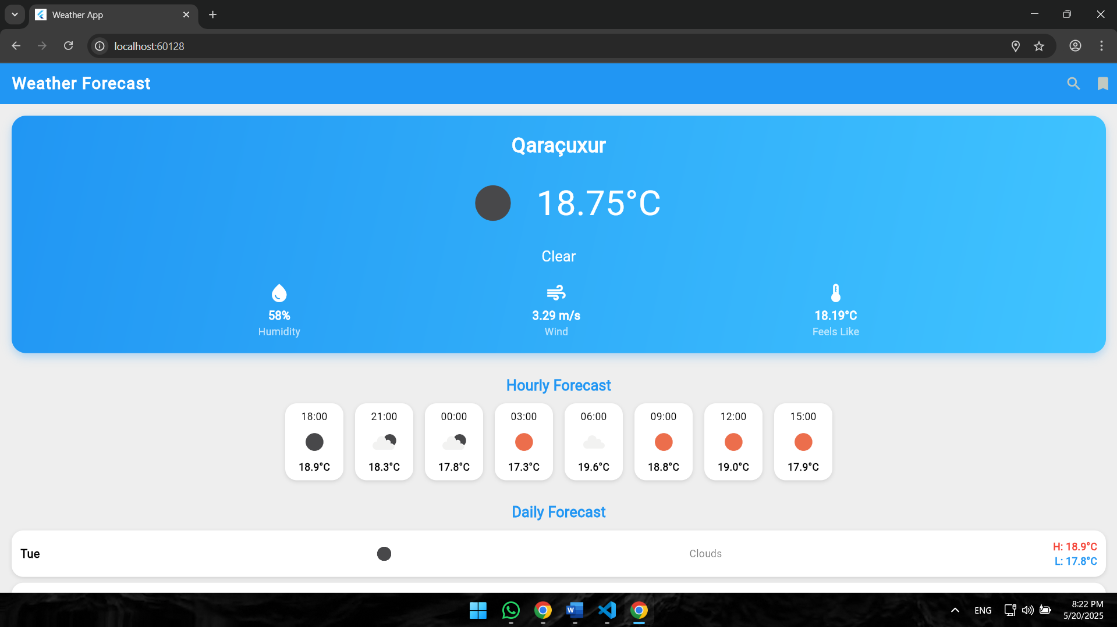



After giving the GPS permission, you will see a page like this (home page).

**HOME PAGE:**

In the home page, the weather in your current location, hourly forecast and daily forecast is displayed.

Also, in the right-up corner, you can see two sections; search button and recent locations button.

**SEARCH BUTTON:**

In the search button, typing the city’s name you want to learn about its weather is enough. After clicking it, you will be able to see the information of the new city.

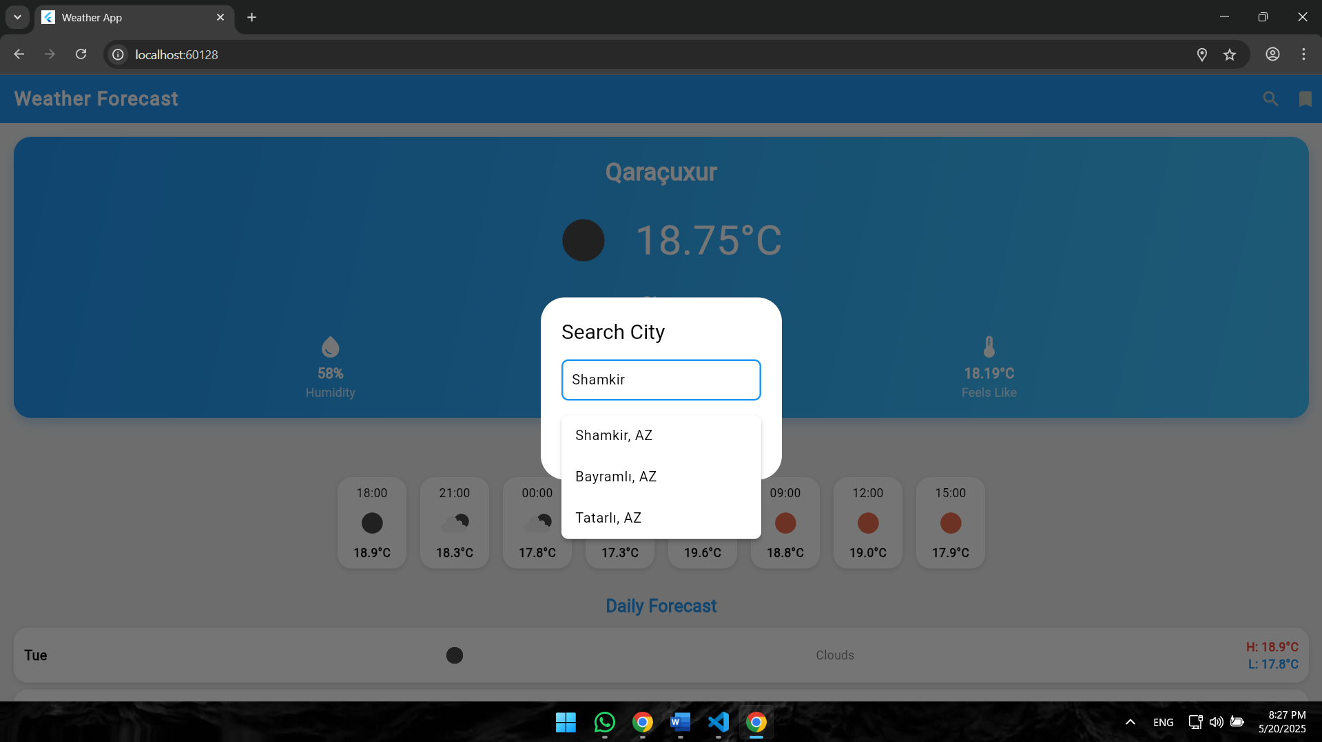



**RECENT LOCATIONS:**

In the recent locations section, you are able to see the locations you have searched before, and also you are able to delete them from this section with the icon of rubbish basket.

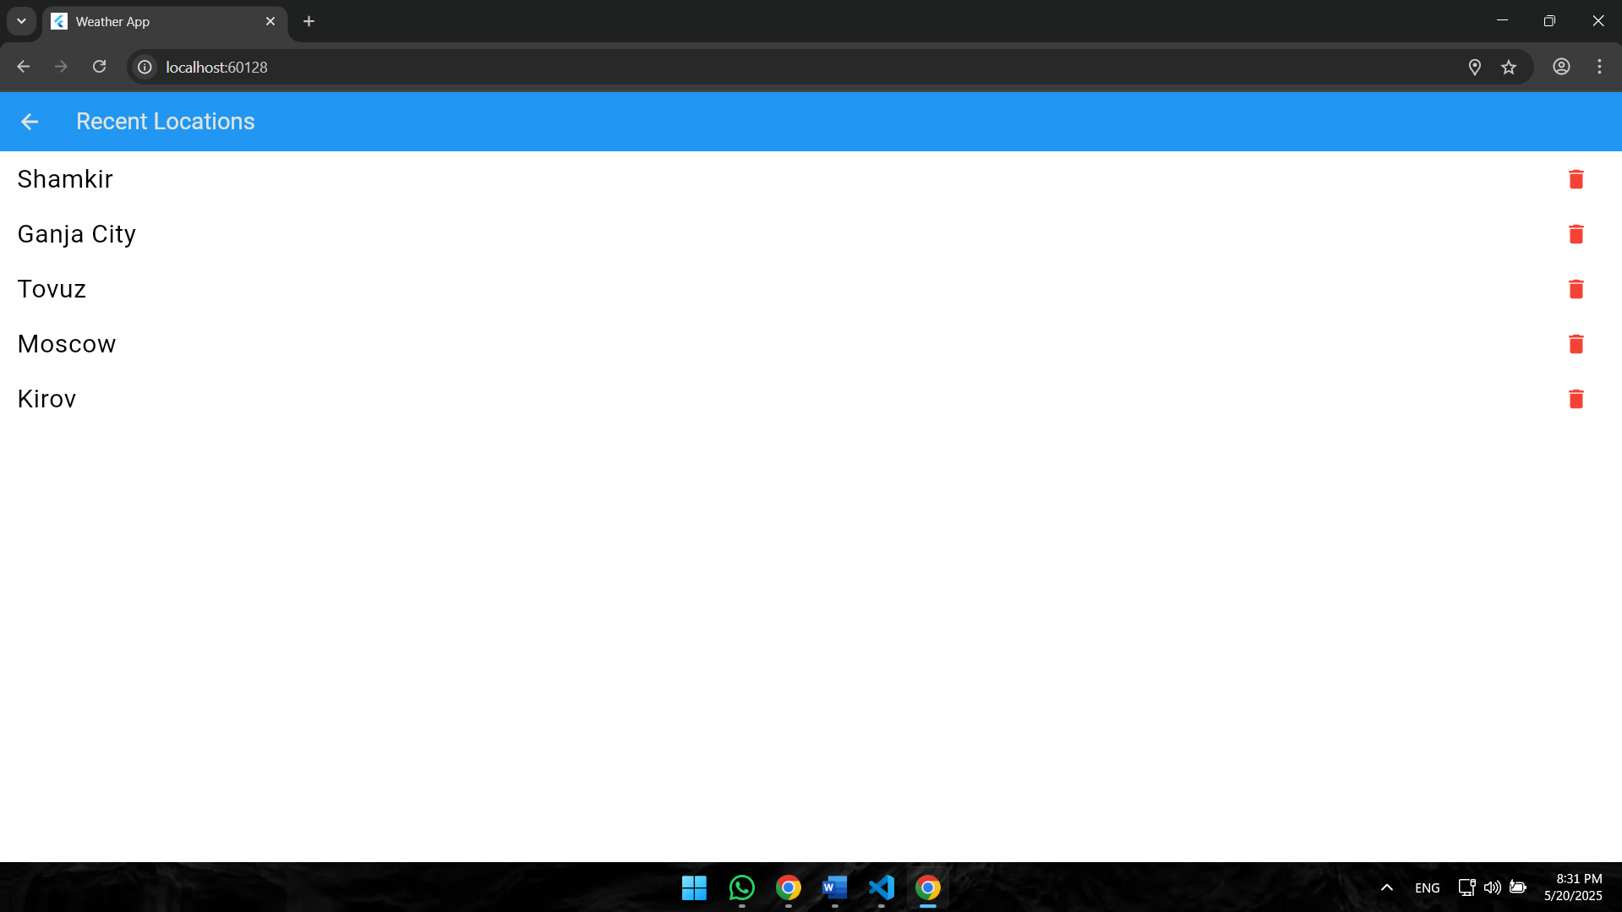



All these information are the guide tutorial of using the Weather Forecast App.